
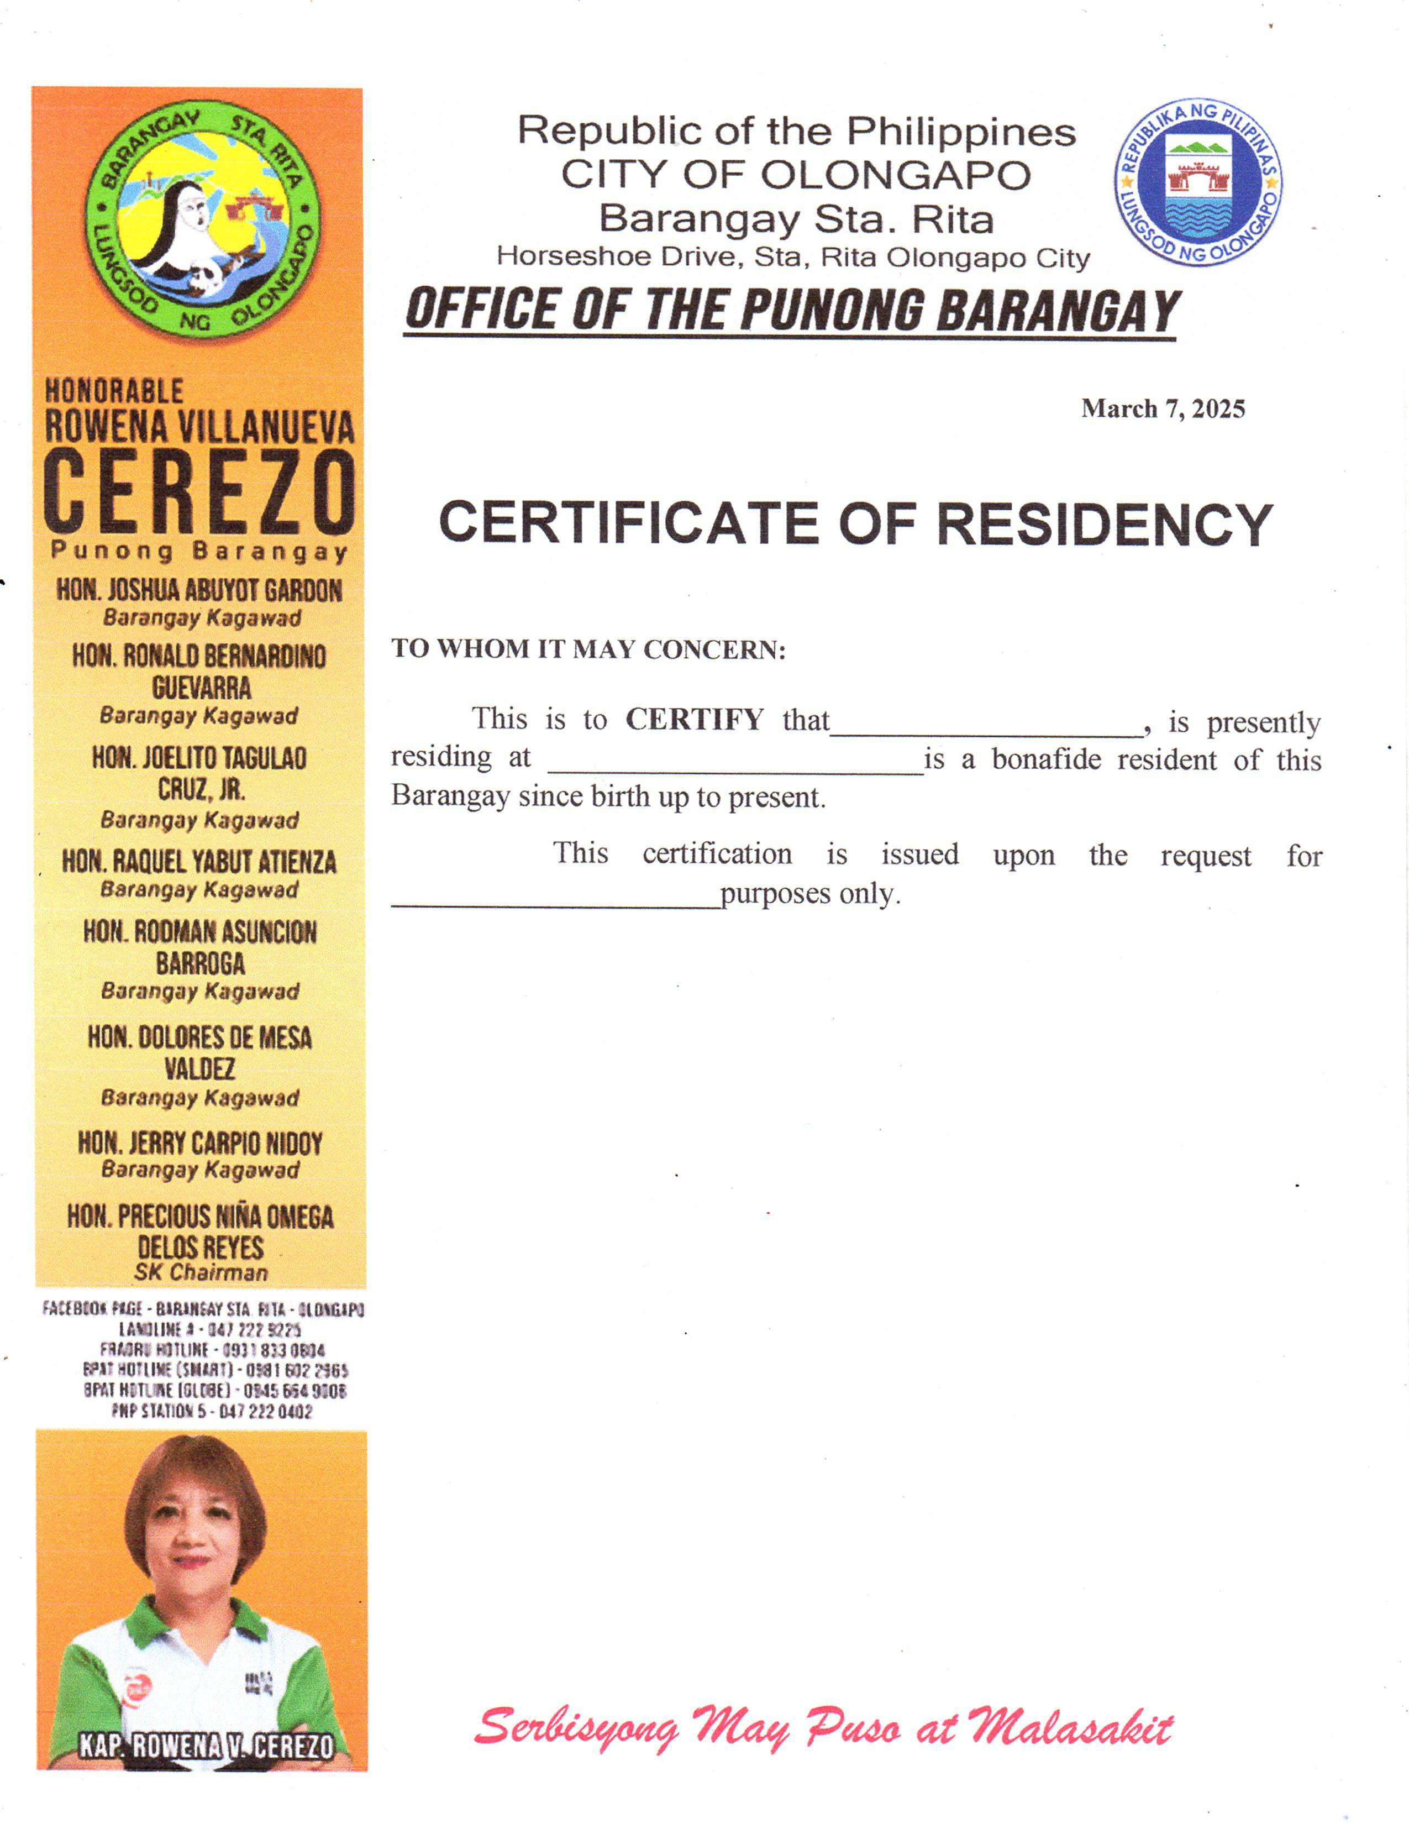
Republic of the Philippines CITY OF OLONGAPO Barangay Sta. Rita Horseshoe Drive, Sta. Rita Olongapo City OFFICE OF THE PUNONG BARANGAY
{dateRequested}

BARANGAY CERTIFICATION

TO WHOM IT MAY CONCERN:
This is to CERTIFY that {honorifics}. {fullName} of legal age, presently residing at {address} is a bonafide resident of this Barangay since birth up to present.

Further CERTIFY that {fullName}, is a FIRST TIME JOB SEEKER after graduating from {schoolName}.
This CERTIFICATION is issued upon the request of {purpose}, for whatever legal purposes only

